## VISVESVARAYA TECHNOLOGICAL UNIVERSITY BELAGAVI-590018



NSS Activity Report (22NS49) Report on Organic Farming

# “Plantation”

Submitted in the partial fulfillment of the requirement for the NSS Activity

### Bachelor of Engineering In

**Information Science And Engineering**

Submitted by

**Ms.Bhavya T S (1NC22IS008)**

**DEPARTMENT OF INFORMATION SCIENCE AND ENGINEERING**



## NAGARJUNA COLLEGE OF ENGINEERING AND TECHNOLOGY

(An Autonomous Institution under VTU, Belgavi-590018) VENKATAGIRIKOTE, DEVANAHALLI, BENGALURU– 562164

**2023-2024**

# NAGARJUNA COLLEGE OF ENGINEERING AND TECHNOLOGY

**(An Autonomous College under VTU, NAAC with “A+”**)

**Bengaluru-562 164, Karnataka, India**

**DEPARTMENT OF INFORMATION SCIENCE AND ENGINEERING**



# CERTIFICATE

This is to Certified that **MS. BHAVYA T S (1NC22IS008)**, bonafied student of Nagarjuna College of Engineering and Technology, an autonomous College under Visveswaraya Technological University, Belagavi carried out “Plantation” for partial fulfillment for the award of Bachelor of Engineering in Information Science and Engineering during the academic year **2023-2024**.

It is certified that all corrections/suggestions indicated for assessment have been incorporated in the report. As it satisfies the academic requirement in respect for the prescribed format.

/100

NSS Activity Marks

**NSS Coordinator**

Department of Information Science and Engineering NCET, Bengaluru

**Signature of the HOD Dr. Sanjeevakumar M Hatture**

Professor and Head

Department of Information Science and Engineering, NCET

## ACKNOWLEDGEMENT

The satisfaction and euphoria that accompany the successful completion of any task would be incomplete without the mention of people who made it possible, whose consistent guidance and encouragement crowned our effort with success. I consider it is our privilege and duty to express our gratitude and respect to all those who guide us in the completion of this project.

First and foremost, it's our immense pleasure to thank our beloved Mentor **Mr. Mohan D N,** Assistant Professor, Department of Information Science and Engineering, Nagarjuna College ofEngineering and Technology, for helping, guiding and strengthening us to complete this AICTE- Activity Report.

I would like to express our sincere thanks to **Dr. Sanjeevakumar M Hatture**, Professor and Head, Department of Information science and Engineering, Nagarjuna College of Engineering and Technology for his valuable suggestions and guidance throughout the period of this NSS Activity.

I take this privilege to express our deep gratitude to **Dr. B V Ravishankar** Principal, Nagarjuna College of Engineering and Technology for his constant support and encouragement in preparation of this report and for providing library and Transportation facilities needed to prepare this NSS Activity Report.

I would like to thank My Beloved Parents for their Support and Encouragement throughout my career. Last but not least, I would like to thank our friends, Teaching and Non-teaching staff of NCET.

BY

Bhavya T S 1NC22IS008

**DECLARATION**

I hereby declare that the NSS Activity report entitled "**Plantation”** submitted by me to Nagarjuna College of Engineering and Technology in partial fulfillment of the requirement for the award of the degree of Bachelor of Engineering in Information Science and Engineering is a record of bonafied report of AICTE activity carried outby me under the **Mentoring** of **Mr. Mohan D N**. I further declare that the work reported here has not been submitted either in part or full, for the award of any other degree in this institute or any other institute or university.

BY

Bhavya T S 1NC22IS008

Table of Content

|  |  |  |
| --- | --- | --- |
| Sl.no | Title | Page No |
| 1 | Introduction | 1-3 |
| 2 | Objective | 3-4 |
| 3 | Procedure followed | 5-13 |
| 4 | Outcome of the Program | 14 |
| 5 | Conclusion | 15 |
| 6 | Reference | 16 |

List of figures

|  |  |  |
| --- | --- | --- |
| Sl.no | Figure Title/ Photos description | Page No |
| 1 | Pic of the plant sapling | 5-8 |
| 2 | Planting a plant | 10 |

### Introduction:

Plantations are extensive agricultural enterprises dedicated to the cultivation of a single major crop or a narrow range of crops. This system of farming, characterized by large-scale, monocultural production, has played a pivotal role in global agriculture and trade. Originating from ancient agricultural practices, the modern concept of plantations took shape during the colonial era, when European powers established vast agricultural estates in tropical regions to meet the growing demand for cash crops like sugar, coffee, tea, and tobacco.

Historically, plantations were central to the economic development of many regions, fueling international trade and shaping local economies. However, they also brought significant environmental and social challenges. The large-scale clearing of land for monoculture crops often led to deforestation and loss of biodiversity, while the reliance on exploitative labor systems, including slavery and indentured servitude, left a legacy of social and economic inequality.

Today, the plantation system continues to evolve, with a growing emphasis on sustainable practices and ethical labor standards. Understanding the historical context and current trends in plantation agriculture is essential for addressing its challenges and shaping a more sustainable future.

A plantation is a large-scale agricultural estate where crops such as cotton, sugar, tobacco, tea, coffee, rubber, or oil palms are grown, usually in a tropical or subtropical region. Historically, plantations were labour-intensive and often relied on a large workforce, including enslaved people or indentured labourers, especially during the colonial era. In the modern era, plantations still exist but have evolved. Some are highly mechanized, and the labour systems have changed, although issues like poor working conditions and environmental degradation remain concerns.

Additionally, large multinational corporations often control modern plantations, influencing global agricultural markets. Plantations typically focus on the cultivation of a single crop on a large scale, which is known as monoculture. This specialization can make them highly efficient but also vulnerable to pests, diseases, and price fluctuations. Plantations are usually found in tropical and subtropical regions, where the climate is suitable for the crops being grown. Plantations have been central to the economies of many regions, especially during the colonial period. They were often established by European colonizers in Africa, Asia, and the Americas to produce cash crops for export. The history of plantations is closely tied to forced labour systems, including slavery and indentured servitude.

After the abolition of slavery, many plantations relied on migrant labour, often under harsh conditions. Plantation agriculture can lead to deforestation, loss of biodiversity, and soil depletion. The large-scale monoculture approach also has significant environmental consequences, such as increased use of pesticides and fertilizers. Plantations were a significant part of European colonial expansion from the 16th to the 19th centuries. Colonizers established plantations in the Americas, Africa, and Asia to grow crops that were in demand in Europe, such as sugar, coffee, and tobacco. In many plantation economies, enslaved Africans were forced to work under brutal conditions. The transatlantic slave trade was closely linked to the growth of plantation economies in the Americas. After the abolition of slavery and the end of colonial rule, plantations continued to operate, often employing local or migrant labour.

The legacy of plantation economies still influences the socio-economic conditions of many regions today. In the modern era, plantations still exist but have evolved. Some are highly mechanized, and the labor systems have changed, although issues like poor working conditions and environmental degradation remain concerns. Additionally, large multinational corporations often control modern plantations, influencing global agricultural markets. Industrial plantations are actively managed for the commercial production of forest products. Industrial plantations are usually large-scale. Individual blocks are usually even-aged and often consist of just one or two species. These species can be exotic or indigenous. The plants used for the plantation are often genetically altered for desired traits such as growth and resistance to pests and diseases in general and specific traits, for example in the case of timber species, volumic wood production and stem straightness. Forest genetic resources are the basis for genetic alteration. Selected individuals grown in seed orchards are a good source for seeds todevelop adequate planting material.

There is a growing movement towards sustainable plantation agriculture. This includes adopting practices that reduce environmental impact, such as agroforestry, organic farming, and integrated pest management. Certification schemes like Fair Trade, Rainforest Alliance, and RSPO (for palm oil) aim to promote ethical and environmentally friendly practices on plantations. Tree plantation is very necessary because trees provide oxygen to the environment and make the air quality better. If more trees are planted, then the world’s environment will become a safer place to live in. tree plantation also reduces pollution, thus making the life of future generations secure. A plantation drive is a community effort to plant trees in particular area. The purpose of plantation drive is to increase the number of trees in area, which provides environmental, economic, and social benefits.

It also promotes an awareness about the importance of tree plantation and encourages people to take the action to protect the environment. Overall, a plantation drive is an excellent way to an promote

environmental conservation and sustainability. The term “plant introduction” describes the movement of agricultural plants from their original growing sites to their locations. In other words, it refers to the process of establishing crop plants in new environment.

As we go about our daily lives, it’s easy to take for granted the many benefits that trees provide. Trees are not only beautiful and majestic, but they also play a crucial role in sustaining life on earth. In this article, we’ll explore the many ways in which trees benefit our environment and our lives. The intensive cultivation practices on plantations can lead to soil exhaustion and degradation. Monoculture depletes soil nutrients, requiring the use of chemical fertilizers, which can further degrade soil quality over time.

In response to these challenges, there is an increasing emphasis on sustainable practices within plantation systems. Modern plantations are adopting techniques to reduce environmental impact, such as integrated pest management and organic farming. Technological advancements are improving efficiency and monitoring, while efforts towards fair trade and ethical labor practices aim to address social concerns.

Plantations are a significant component of global agriculture with a complex legacy of economic impact and environmental and social challenges. Understanding the historical evolution and contemporary practices of plantations is crucial for addressing the issues they pose and for developing strategies that promote sustainability and equity in agricultural systems.

**OBJECTIVE OF PLANTATION:**

It has been observing by the people that nature has been changing itself very tremendously as we are responsible for this change because of building and constructive more and more cities and towns. As road widening took place, many grownup trees were cut down. During the last two years there are exorbitant changes in the weather. Water table in our area has gone down drastically. Therefore, we have to maintain this balance by following the given points:

* To ensure more plantation of different fruits and other useful plants trees. Plantation programme can become more popular. So, it is our duty to promote more and more students to come forward for planting trees.
* To increase the values of plants environment among the students. The Context The very noble objective of “Plantation programme is to save protect the environment by plantation work” with under given points:
* To increase the level of the student thinking regarding the plantation work.
* To ensure the sincerity of the students regarding the values of trees plants.
* To inculcate the programme of plantation can change the heart hobbies of students to produce more and more oxygen.
* For the maintenance the cycle of the nature for upgradation of the environment.
* By planting more trees we can reduce not only the heat but also attract clouds for better rain fall.

The Practice It is very important to plant more and more trees, herbs and climbers because these are the carriers of rain and cloud. Only the nature has capacity to turn up the balance of nature to produce more and more oxygen, but it is only possible when our surroundings are full of trees and plants. Such type of Programme is only possible when our new generation become more more sincere and active towards plantation programme. If our programme of plantation makes the points of success, it is sure and certain that our nature will be in balance and the life of the people can be happy peaceful. So, we should plant more more trees and protect them for the future of new generation. Evidence of Success Our efforts of plantation work provoke the heart of the students and inspired them to go quickly on the path of plantation for the balance of the nature up-gradation of environment. It is the result of the programme that more than 70 student participated in the programme of the plantation started by college administration. As soon as possible to 250 plants has been planted by the students around the college campus. About thousand Mud balls containing seeds were scattered in the neighbouring empty places. The rains in the month of June and July sprouted the seeds in the mud balls and new greenery spread in the neighbour hood. These plants and planted trees will provide us a feeling of true nature beauty of the nature. Problems Encountered and Resources Required Some students were unwilling to participate in the plantation activity. But our committed members in the Eco club convinced them through screening documentaries and distributing news items ultimately they convinced the students about the impending dangers and made them realize the importance of the nature and environment. They maintained plant bank of about five hundred plants on the campus and distributed them to the public.

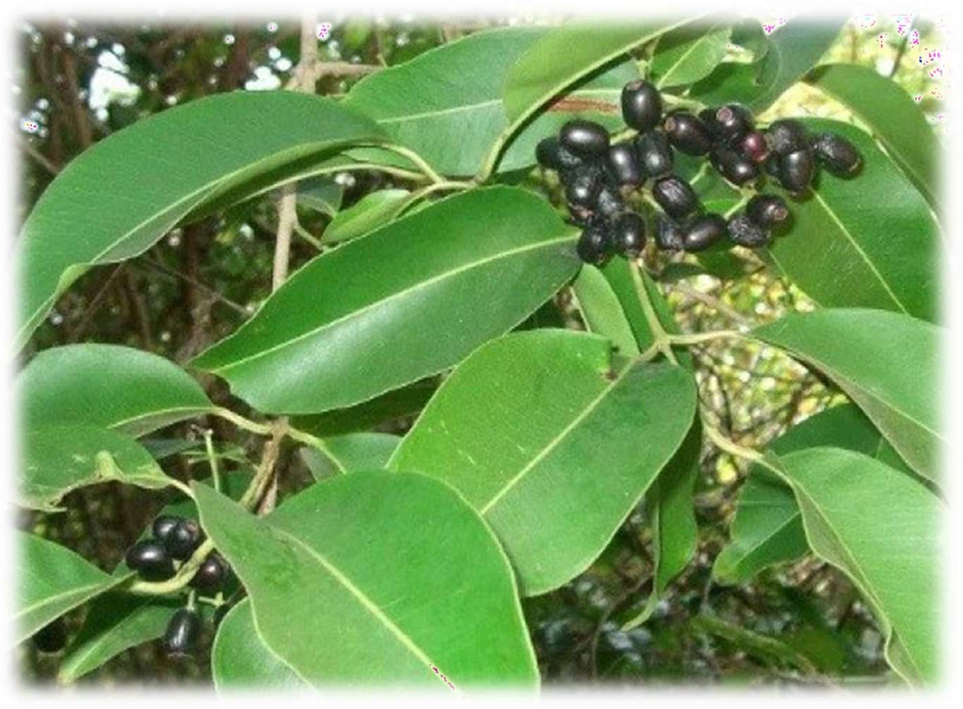

**FIG.1.1 Jamun Plant**

## PROCEDURE FOLLOWED:

Jamun (Syzygium cumini), also known as Indian blackberry or black plum, is a tropical fruit tree valued for its sweet and tangy fruit as well as its medicinal properties. Establishing a jamun plantation involves several key steps, each aimed at ensuring successful growth and production. Here’s a comprehensive guide for jamun plantation

Select a plant species or variety that is well-suited to your local climate, soil type, and garden conditions. Choose a planting site that provides the necessary conditions for the plant to thrive, such as adequate sunlight, space, and drainage. For roses, select a spot that receives at least 6 hours of direct sunlight daily. Test the soil to determine its pH and nutrient levels. Roses, for example, prefer slightly acidic soil with a pH between 6.0 and 7.0. Improve the soil by adding organic matter like compost or well-rotted manure to enhance fertility, structure, and drainage. Depending on your choice, you will need either a young plant (bare root or potted) or seeds. Gather essential gardening tools such as a shovel, trowel, watering can or hose, mulch, and fertilizer. Prepare mulch (such as wood chips or straw) to help retain moisture and suppress weeds, and a balanced fertilizer to promote growth. The best time to plant most shrubs, including roses, is in the spring or fall when the weather is cool and the plant can establish roots before the extreme heat or cold. Dig a hole that is wide and deep enough to accommodate the root system. For roses, the hole should be about twice the width of the root ball and deep enough to position the bud union (where the rose is grafted onto the rootstock) just above or slightly below the soil line,

depending on your climate. If you’re planting a bare root rose, soak the roots in water for a few hours before planting. Create a small mound of soil at the bottom of the hole, place the roots over the mound, and spread them out evenly. For potted roses, gently remove the plant from the pot, being careful not to damage the roots. Place the plant in the hole at the same depth it was growing in the pot. Fill the hole with soil, gently firming it around the roots to eliminate air pockets. Water thoroughly to help the soil settle and establish good contact with the roots. Water the plant thoroughly after planting to ensure the roots are well-hydrated and the soil is settled. Water regularly, especially during dry spells Water at the base of the plant to avoid wetting the leaves, which can lead to fungal diseases.Spread a 2-3 inch layer of mulch around the base of the plant, but keep it away from the stem to prevent rot. Mulch helps retain moisture, regulate soil temperature, and suppress weeds. Wait until after the plant has been in the ground for a few weeks before applying fertilizer. Use a balanced fertilizer or one specifically formulated for jamun plant.

Fertilize regularly during the growing season, typically every 4-6 weeks. Reduce or stop feeding in late summer to avoid encouraging new growth that could be damaged by frost. If planting a tall or climbing rose, provide support with a stake, trellis, or other structure. Tie the plant loosely to the support using soft ties to prevent damage. After planting, prune any dead or damaged stems to encourage healthy growth. Prune roses in late winter or early spring to shape the plant, remove dead or weak wood, and encourage vigorous growth and blooming. Regularly inspect the plant for signs of pests or diseases. Common rose pests include aphids, spider mites, and Japanese beetles, while diseases like black spot, powdery mildew, and rust can affect roses. Use organic or chemical treatments as necessary, and practice good garden hygiene to minimize disease risk. Remove any fallen leaves or debris that could harbor pests or pathogens. Regularly remove spent flowers to encourage more blooms and keep the plant looking tidy. In colder climates, protect the plant from winter damage by applying a thick layer of mulch around the base, covering the crown, or using a rose cone. Keep an eye on how the plant is growing and make adjustments as needed. If the plant isn’t thriving, consider adjusting watering, fertilization, or soil conditions. Continue to care for the plant through regular watering, feeding, pruning, and monitoring for pests and diseases. With proper care, your plant should thrive and produce beautiful blooms or healthy growth for years to come. The procedure followed in a plantation program is a carefully planned and methodical process designed to ensure the successful establishment and long-term sustainability of the planted area. It begins with a thorough site assessment, where factors such as soil type, climate, water availability, and existing vegetation are evaluated. This assessment helps in selecting the appropriate species for planting, ensuring that they are well-suited to the local environment and have the best chance of thriving. Following the site assessment, the land is prepared for planting. This step

may involve clearing the area of invasive species, debris, or existing vegetation that could compete with the new plants. Soil preparation is also critical, often requiring plowing, tilling, or the addition of organic matter to improve soil structure and fertility. In some cases, soil testing is conducted to determine nutrient levels and pH, guiding the application of fertilizers or lime to create optimal growing conditions. Once the site is prepared, the selection of plant species takes place. Native species are often preferred for their adaptability to the local environment and their role in supporting native wildlife. In addition, fast growing species may be chosen to provide quick canopy cover, while slower-growing, hardwood species may be included for long-term benefits.

The species mix is carefully planned to create a balanced ecosystem that meets the specific goals of the plantation, whether they are ecological restoration, timber production, or agroforestry. Planting typically occurs during the rainy season or a period of adequate moisture to ensure high survival rates. Seedlings are planted at specific intervals, considering the space needed for each species to grow to maturity. Proper planting techniques are crucial, including digging holes of appropriate depth, handling seedlings gently to avoid root damage, and firming the soil around the roots to eliminate air pockets. After planting, the focus shifts to maintenance and care, which are vital for the success of the plantation. Regular watering, especially during dry spells, helps young plants establish strong root systems.

Mulching is often used to retain soil moisture, suppress weeds, and provide nutrients as it decomposes. Pruning and thinning may be necessary to shape the trees, remove diseased or dead branches, and ensure that the remaining plants have enough space and resources to grow healthily. Integrated pest management (IPM) techniques are employed to protect the plants from pests and diseases, using a combination of biological controls, such as introducing natural predators, and minimal chemical interventions. Monitoring and evaluation are continuous processes, with regular checks on plant health, growth rates, and overall ecosystem development.

Data collected during these evaluations guide any necessary adjustments to the plantation management plan. Finally, the plantation may involve community participation, where local people are engaged in the planting and maintenance activities, fostering a sense of ownership and responsibility towards the project. Education and training programs are often implemented to build local capacity for sustainable land management, ensuring the long-term success and sustainability of the plantation.

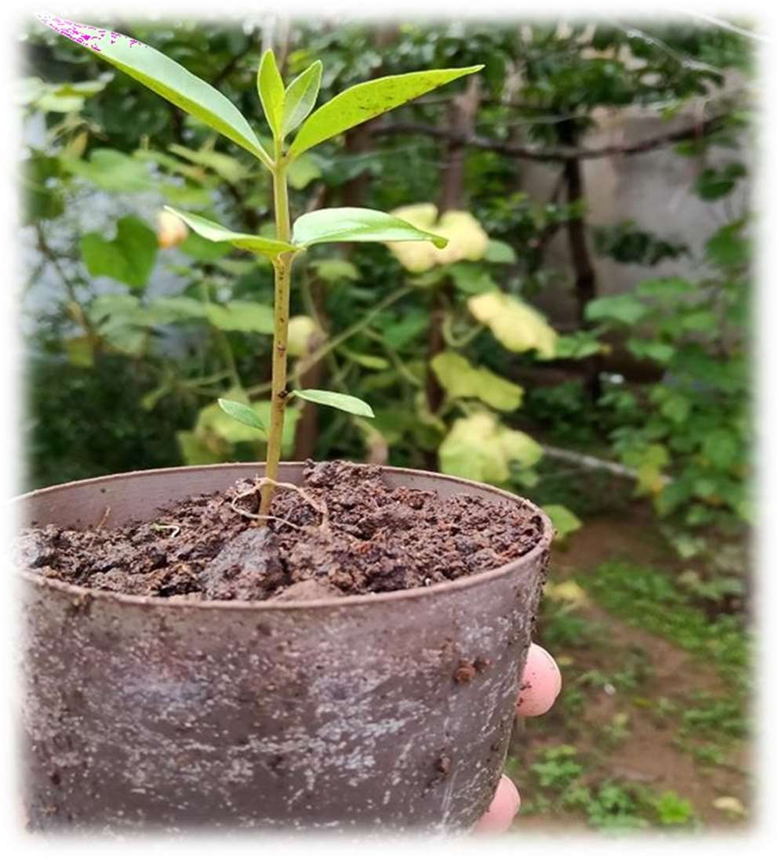

**FIG 1.2**

# About plant :

### Table 1: Nutritive value of Jamun fruit:

|  |  |  |
| --- | --- | --- |
| **Sl.No** | **Nutrient** | **Percentage** |
| 1 | Moisture | 28.2 |
| 2 | Protein | 0.7 |
| 3 | Fat | 0.1 |
| 4 | Mineral | 0.4 |
| 5 | Fibre | 0.9 |
| 6 | Carbohydrate | 19.7 |
| 7 | Calcium | 0.02 |
| 8 | Phosphorus | 0.01 |
| 9 | Iron | 1.0 |
| 10 | Calorific value | 83/100 g |

The tasty and pleasantly flavoured fruit is mostly used for dessert purposes. The fruit is usually eaten with salt. The jamun fruit has sub-acid spicy flavour. Apart from ~ating fresh, it can be used for making delicious beverages, jellies, jam, squash wine, vinegar and pickles. Jamun squash is a very refreshing

drink in summer season. A little quantity of fruit syrup is very useful for curing diarrhoea. A mixture of jamun juice and mango juice in equal quantity is very useful for quenching thirst for diabetic patient. Jamun is used for preparation of wine particularly in goa. The vinegar prepared from juice extracted from slightly ripe fruits is stomachic, carminative and diuretic, apart from having cooling and digestive properties. Almost every part of the tree is used for one purpose or other. A tree made of tender leaves and alcoholic extracts of leaves and fruits is used in South America for curing the stomach disorder. Powdered seeds are also very useful for the cure of diabetes.

The seed powder of jamun reduces the quantity of sugar in the urine very quickly and permanently. It is used as a lotion for the cure of ring worm. Jamun seeds can be used as a concentrate for animals because itis rich in protein, carbohydrate and calcium. Its wood is used for manufacturing railway sleepers. It is not attacked by wood decaying insects or fungi. There are a lot of other uses of jamun fruits too.

The fruit of the Jamun plant is a small, oval-shaped berry that turns from green to a deep, purplish-black as it ripens. This transformation occurs in the summer months, making Jamun a seasonal favorite in many regions. The fruit has a unique taste that combines sweet and tart flavors, making it popular for both raw consumption and culinary uses. The Jamun berry is not only delicious but also packed with nutrients. It is rich in vitamins A and C, iron, calcium, and various antioxidants, making it a healthy choice for those looking to boost their diet. In traditional medicine, the Jamun fruit, particularly its seeds, is revered for its potential to help manage diabetes. The seeds contain compounds that help regulate blood sugar levels, making them a natural remedy for this common condition. Additionally, the fruit is known to aid in digestion and is often used to treat a range of stomach disorders, including dysentery and diarrhea.

In summary, the Jamun plant is a versatile and valuable tree, known for its delicious and nutritious fruit, as well as its medicinal properties. Its ability to thrive in tropical climates, coupled with its low maintenance requirements, makes it an ideal choice for a variety of landscapes. Whether grown for its fruit, its shade, or its cultural significance, the Jamun tree remains an important part of the botanical and agricultural heritage of the regions where it is cultivated.

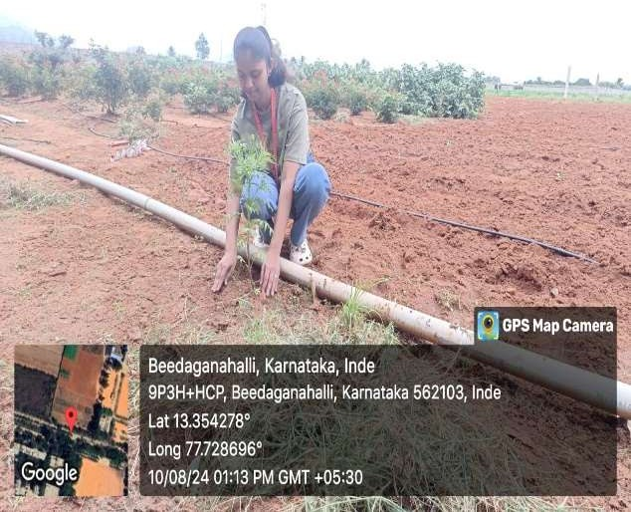

**FIG 1.3 Planting jamun plant**

### Key Characteristics:

**Leaves:** The leaves are glossy, leathery, and oblong with a smooth texture.

**Flowers:** The plant produces small, fragrant, white to pinkish flowers, usually in clusters, during the spring season.

**Fruits:** The fruit is a small, purplish-black berry with a sweet-tart taste, ripening in the summer. It contains a single seed.

### Health Benefits:

**Nutrient-Rich:** Jamun is rich in vitamins A and C, iron, calcium, and various antioxidants.

**Diabetes Management**: The seeds of the Jamun fruit are particularly known for their anti-diabetic properties, as they help regulate blood sugar levels.

**Digestive Health**: The fruit is beneficial for digestion and is often used to treat stomach disorders.

### Uses:

**Culinary:** Jamun fruit can be eaten raw, used in salads, or processed into jams, jellies, and beverages.

**Medicinal:** Various parts of the Jamun plant, including the bark, leaves, and seeds, are used in traditional medicine for treating ailments like diabetes, diarrhea, and infections.

### Cultivation:

Jamun plants thrive in tropical and subtropical climates and prefer well-drained, loamy soil. They are relatively drought-resistant but require regular watering, especially when young. The plant is valued for both its fruit and its medicinal properties, making it a significant addition to home gardens and commercial plantations.

Beyond its culinary and medicinal uses, the Jamun plant holds a special place in many cultures. In India, for example, the tree is often planted in home gardens, not just for its fruit, but also for its shade and aesthetic value. The tree’s wood is hard and durable, making it useful for various purposes, including construction and furniture making. Cultivating Jamun trees requires a warm, tropical or subtropical climate, as they thrive in areas with abundant sunlight and well-drained, loamy soil. While the tree is relatively drought-resistant, young plants need regular watering to establish a strong root system. Once mature, the Jamun tree requires minimal care, making it a popular choice for both small-scale and commercial farming.

### Advanced Care Techniques:

Advanced care techniques in plantation management are essential for maximizing the growth, health, and sustainability of planted ecosystems. One such technique is precision forestry, which involves the use of technology like GPS, drones, and remote sensing to monitor tree growth, soil health, and environmental conditions. This data-driven approach allows for targeted interventions, such as precise watering, fertilization, and pest control, which minimize resource use and environmental impact. Another advanced technique is the practice of soil enhancement through biochar application and mycorrhizal fungi inoculation. Biochar improves soil structure, enhances nutrient retention, and increases carbon sequestration, while mycorrhizal fungi form symbiotic relationships with tree roots, boosting nutrient uptake and resilience against diseases. Additionally, integrating agroforestry practices, where trees are planted alongside crops, enhances biodiversity, improves soil fertility, and creates a more resilient agricultural system. Water management is also a critical aspect of advanced plantation care.

Techniques like drip irrigation and rainwater harvesting ensure that water is used efficiently, reducing wastage and ensuring that plants receive the right amount of moisture. Mulching with organic materials not only conserves water but also suppresses weeds and adds nutrients to the soil as it decomposes. Genetic improvement and selective breeding of plant species are other advanced strategies used to develop trees that are more resistant to pests, diseases, and changing climate conditions. These improved species often have faster growth rates and higher yields, making plantations more productive and sustainable. Incorporating these advanced care techniques ensures that plantations are not only successful in their initial establishment but also thrive in the long term, contributing to environmental sustainability, economic viability, and social well-being.

## TOOLS USED:

Various tools are essential in plantation activities, each designed to enhance efficiency and ensure the successful growth of plants and trees. Basic hand tools like shovels, spades, and hoes are fundamental for digging, planting, and preparing the soil. They help create planting holes, mix in compost or fertilizers, and manage weeds, ensuring that the soil is in optimal condition for plant growth. Pruners and loppers are crucial for maintaining plant health by trimming branches and removing dead or diseased parts. This not only shapes the plants but also encourages new growth and prevents the spread of diseases. For larger branches or more extensive pruning tasks, saws are often used, providing the necessary cutting power for thicker wood. Watering tools, such as hoses, sprinklers, and drip irrigation systems, are vital for ensuring that plants receive adequate moisture. Drip irrigation, in particular, is a highly efficient method that delivers water directly to the roots, reducing water wastage and promoting deep root growth. Mulching tools, like wheelbarrows and rakes, are used to apply and spread mulch around the plants, which helps conserve moisture, regulate soil temperature, and suppress weeds. More advanced tools include soil testing kits and pH meters, which help assess the soil’s nutrient levels and acidity, allowing for more precise soil amendments and fertilization. GPS devices and mapping software are increasingly used in larger plantations to plan layouts, monitor plant growth, and track maintenance schedules. For pest control, tools like sprayers are used to apply pesticides or organic treatments that protect plants from insects and diseases. In eco-friendly plantations, integrated pest management (IPM) tools, such as traps and biological controls, are employed to minimize chemical use and promote a healthy ecosystem. Mechanical tools like tractors, tillers, and plows are often employed in larger plantations to prepare the land, manage large areas of soil, and perform heavy-duty tasks that would be labor-intensive if done manually.

### Economic Significance:

Plantations play a crucial role in the global economy by producing high-value crops that are essential for both domestic consumption and international trade. They enable economies of scale, allowing for efficient production and large yields. The economic benefits of plantations are evident in their contribution to local economies, job creation, and infrastructure development. However, the benefits are not always evenly distributed, and plantations can be subject to economic volatility based on global market conditions.

### Environmental and Social Impacts:

While plantations drive economic growth, they also present significant environmental and social challenges. The large-scale clearing of land for monoculture crops can lead to deforestation, loss of biodiversity, and soil degradation. Additionally, the reliance on chemical inputs can contribute to pollution. Socially, the history of plantations includes a legacy of exploitation and inequality, with labor practices that have often been harsh and inequitable.

### Modern Developments;

In response to these challenges, there is an increasing emphasis on sustainable practices within plantation systems. Modern plantations are adopting techniques to reduce environmental impact, such as integrated pest management and organic farming. Technological advancements are improving efficiency and monitoring, while efforts towards fair trade and ethical labor practices aim to address social concerns.

### Modern Trends and Future Directions:

In recent years, there has been a growing awareness of the need for more sustainable and ethical practices in plantation agriculture. Modern plantations are increasingly adopting practices that aim to mitigate environmental impacts, such as integrated pest management, agroforestry, and organic farming. Technological advancements, including precision agriculture and remote sensing, are enhancing efficiency and environmental stewardship.

## OUTCOME OF THIS PROGRAMME:

The outcome of a well-executed plantation program is multifaceted, resulting in significant environmental, social, and economic benefits. Environmentally, such a program leads to increased green cover, which enhances biodiversity by providing habitats for various species and contributing to ecosystem stability. The trees planted help sequester carbon dioxide, thereby mitigating the effects of climate change and improving air quality. Soil health is also improved, as tree roots prevent erosion, increase water retention, and enrich the soil with organic matter. Socially, the program fosters community engagement and education, raising awareness about the importance of environmental conservation. It can create opportunities for local employment in tree planting, maintenance, and related activities, which helps to uplift communities economically.

The green spaces developed through the program provide recreational areas for people, enhancing their quality of life and mental well-being. Economically, the program can lead to the sustainable production of resources such as timber, fruits, and other non-timber forest products, which can be harvested and sold, generating income for communities and contributing to local economies.

The increased green cover also has long-term economic benefits by reducing the impacts of natural disasters, such as floods and droughts, which can save costs related to disaster management and recovery. In urban areas, the outcome includes the creation of urban forests and green belts, which not only beautify the surroundings but also help reduce the urban heat island effect, making cities more livable. Furthermore, the program’s success contributes to meeting national and global environmental goals, such as those outlined in climate action plans and the United Nations Sustainable Development Goals (SDGs). Overall, the outcome of a plantation program is a healthier, more resilient environment, improved livelihoods for local communities, and a stronger connection between people and nature, leading to sustainable development and a better future for all.

## CONCLUSION:

Plantation is a vital practice that significantly contributes to environmental sustainability, agricultural productivity, and aesthetic value in our surroundings. By carefully selecting, planting, and nurturing various plants, individuals and communities can reap numerous benefits, including improved air quality, enhanced biodiversity, and the enjoyment of beautiful landscapes. Whether planting for personal enjoyment, agricultural purposes, or ecological restoration, the process requires careful planning, proper tools, and ongoing care to ensure success. Ultimately, plantation not only enriches our lives by providing food, beauty, and ecological balance but also plays a crucial role in combating environmental challenges such as climate change and habitat loss. Through thoughtful and responsible plantation practices, we can help create a greener, healthier planet for future generations. Planting trees and other vegetation plays a crucial role in mitigating climate change by absorbing carbon dioxide from the atmosphere. Forests and plantations act as carbon sinks, helping to reduce greenhouse gases and combat global warming. Plantations support biodiversity by providing habitats for a wide range of species. Diverse plantings, including native species, can create ecosystems that sustain wildlife, promote pollination, and preserve the natural balance of the environment. Plants and trees help prevent soil erosion by stabilizing the soil with their root systems. This is particularly important in areas prone to erosion, where vegetation can prevent land degradation and maintain soil fertility. Plantation activities often bring communities together, fostering collaboration and shared responsibility for the environment. Community-driven planting projects can enhance social cohesion and promote environmental stewardship. Many cultures have deep connections with certain plants and trees, which are often integral to traditions, rituals, and local identity. Preserving and planting these species helps maintain cultural heritage and knowledge. Beyond their functional roles, plantations enhance the beauty of landscapes, providing spaces for recreation, relaxation, and spiritual renewal.

Parks, gardens, and green spaces improve the quality of life by offering areas for leisure and connection with nature. plantation is a multifaceted activity with far-reaching benefits for the environment, economy, and society. It is a proactive step toward environmental conservation, economic development, and social well-being. By adopting sustainable practices, engaging communities, and considering the broader implications of plantation activities, we can ensure that the benefits of plantation are maximized while minimizing potential drawbacks. The act of planting today is an investment in a healthier, more sustainable, and more beautiful world for future generations.

## REFERENCES:

**"Plantation Forestry in the Tropics: Principles and Practice"** by David L. D. M. Matthews. **"Agroforestry for Natural Resource Management"** by K. A. A. Naidu and J. J. R. S. Mahapatra. **"Restoration Ecology: The New Frontier"** by John A. Harris.

**"Ecological Restoration"** by Andre F. Clewell and James Aronson.